

Crossroads   
Release Notes

Release xxxxx [PR_4292]

Revision 1.0

08/27/2014

**Code Release Checklist**

Product/Application/Service: Crossroads

Release Notes: __X__

Build Kit Identification: _Crossroads6.28.10 _________________

Directory/Table changes required: None

Scheduled Release Date: 09/01/2014

OS release is being tested with: Linux

OS patch version level _RHEL5.6 2.6.18-238.5.1.el5

Third party software version:

System Test: Development:

Iplanet Web Server 7 SP6 Iplanet Web Server 7 SP6

Iplanet Directory Server 5.2 Iplanet Directory Server 5 SP2

Proxy Server: OHS 11.1.1.7/ Proxy Server: OHS 11.1.1.5/

Apache 2.2.15 Apache 2.2.15

Java JDK 1.6.0_24 Java JDK 1.6.0_24

Development Resource On Call:

Name: Gaurav Sharma (Primary)

Phone: 813-610-1082 (Mobile)

813-774-4552 (Home)

Name: Sarath Mani (Secondary)

Phone: 813-484-0016 (Mobile)

813-333-5822 (Home)

Name: Jim Paauw (Secondary)

Phone: 813-493-2467 (Mobile)

727-527-3195 (Home)

Tested

Browser levels _____ IE 8.0 _____

Testing Completed By: _Centralized Test –

Comments: Please list any dependencies that this release may have in relation to other aapplication(s) releases.

Premium Customer Services (PCS) 2.5 :

**Revision History**

|  |  |  |
| --- | --- | --- |
| **Revision Number** | **Date** | **Reason** |
| 1.0 | 08/27/2014 | Initial Release |

**Table of Contents**

1 Release Overview 5

1.1 Overview 5

1.1 Premium Customer Services (PCS) 2.5 [PR_4292] 5

1.2 Customer Impact 5

1.3 Processor Impact 5

1.4 Data Impact 5

1.5 Interfacing or Related System Impact 5

1.6 Network Impact 6

1.7 Data Center Impact 6

2 Changes 7

2.1 Tables/Files 7

2.2 Job Processing 7

3 Implementation Tasks 7

3.1 Release Procedures 7

3.1.1 Pre-Release Requirements 7

3.1.2 Crossroads – Director 8

3.2 Backout Procedure 10

3.3 Monitoring/Verification Procedures 11

3.3.1 Premium Customer Services (PCS) 2.5 11

• Syniverse Company 11

• Syniverse User 11

• Customer Test Company 12

• Customer Test Company User 12

4 Test Procedures 14

# Release Overview

## Overview

This release includes the following:

## Premium Customer Services (PCS) 2.5 [PR_4292]

**The Premium Customer Services (PCS) 2.5 functional design document explains all the functionalities.**

**Here is the Design document link:**

[xxxxxx](http://central.syniverse.com/sites/TECH/arch/Crossroads/Release%20Documentation/Crossroads%20Design%5bVisProactive%20Diameter%5d.docx)

**Note: Please check the Section 3.3 MONITORING/VERIFICATION PROCEDURES for more description and screen-shots.**

Risks

## Customer Impact

None

## Processor Impact

Negligible

## Data Impact

None

## Interfacing or Related System Impact

Premium Customer Services (PCS) 2.5 :

Crossroads release can be installed first, but the Premium Customer Services (PCS) 2.5 related perms will not be available until Premium Customer Services (PCS) 2.5 release is installed.

## Network Impact

None

## Data Center Impact

No additional impact.

# Changes

## Tables/Files

No changes.

## Job Processing

No changes.

# Implementation Tasks

This section describes in detail the steps that need to be performed to install this software release. Each step should be completed and verified before proceeding to the next step. Any queries should be directed to the development team.

## Release Procedures

#### Pre-Release Requirements

##### DNS Requests

##### Request the following DNS entries as CNAMEs to crossroads.syniverse.com:

* pcs.syniverse.com [PROD]

**Functional User ID**

No new functional ID is required.

#### Crossroads – Director

|  |  |
| --- | --- |
|  | **Software Install** |
| Note: | **Crossroads release can be installed first, but the Premium Customer Services (PCS) 2.5 related pod links will not work utill Premium Customer Services (PCS) 2.5 release is installed.** |
|  | **Web Tier – httpd.conf** |
|  |  |
| Step 1 | This step is NOT needed |
| Step 2 | Restart the OHS proxy server:  **Stop OHS instance (if applicable):**  #opmn-stop  #opmn-start |
| Step 3 | Transfer the tar file from hwcmb01:  /ccm_builds/crossroads/release_output6.28.10/2014MMDD/*CrossRoads6.28.10.2014MMDD.tar*  to the application tier servers.  The exact file name will be provided in the signoff email.  **Production steps:**  **As your own ID:**  # cd /tmp  # scp hwcmb01:/ccm_builds/crossroads/release_output6.28.10/2014MMDD/CrossRoads6.28.10.2014MMDD.tar .  # ssh hwcmb01 cksum /ccm_builds/crossroads/release_output6.28.10/2014MMDD/CrossRoads6.28.10.2014MMDD.tar  # chmod 777 CrossRoads6.28.10.2014MMDD.tar  **sudo to xroads**  # sudo su - xroads  **Move the release tar to /share1/xroads/releases:**  # cd /share1/xroads/releases  # mv /tmp/CrossRoads6.28.10.2014MMDD.tar .  # cksum CrossRoads6.28.10.2014MMDD.tar  **Ensure the cksum's match.** |
| Step 4 | From the /crossroads directory, extract the contents of the tar file from the Crossroads 6.28.10 build.  tar -xvmf CrossRoads6.28.10.2014MMDD.tar  **Production steps:**  # cd /crossroads  # cp /share1/xroads/releases/CrossRoads6.28.10.2014MMDD.tar .  # tar -xvmf CrossRoads6.28.10.2014MMDD.tar ./cgi-bin/GenerateLDIF  # tar -xvmf CrossRoads6.28.10.2014MMDD.tar ./cgi-bin/grantPermissions |
|  | **LDAP Scripts** |
| Step 1 | Execute the following command from the /crossroads/cgi-bin directory:    ./GenerateLDIF PCSPhase2_5 |
|  | **Import LDIF files into LDAP Directory** |
| Step 1 | **Production:** FTP the ldif files from the previous step to the LDAP Directory server - crossroads-dir4. |
| Step 2 | Change to the following directory (on the LDAP directory server for Production):  **Production:**  /usr/netscape/server4/cgi-bin  **System Test:** /crossroads/cgi-bin |
| Step 3 | Execute the following command from the cgi-bin directory above (Step 2):  ./addLDIF PCSPhase2_5.ldif –e PCSPhase2_5.rejects |
| Step 4 | Examine these rejects file for any errors.  PCSPhase2_5.rejects  Contact development if errors occur. |
|  | **- Execute SQL commands** |
| Step 1 | From the /crossroads/cgi-bin directory on the crossroads app tier server,  Execute this command  **source setClassPath.sh**  Now execute the following commands:  ./runSqlRunner.sh ./PCSPhase2_5.sql  The .err and .status files should be checked for successful completion.  The .out file contains the details of what was executed and can be used to troubleshoot issues if needed. |
|  |  |
|  | **Grant Permissions** |
|  | From the /crossroads/cgi-bin directory on the crossroads app tier server,  Execute this command if not already executed above.  **source setClassPath.sh** |
| Step 1 | Execute the following command from the /crossroads/cgi-bin directory:  ./grantPermissions PCSPhase2_5  Make sure that following files are generated after running the above grantPermissions  PCSPhase2_5.grantPermission.sql  If this .sql file is not generated then don’t proceed further. |
| Step 2 | If the above grantPermissions is successful then execute the SQL from the /crossroads/cgi-bin dir  ./runSqlRunner.sh ./PCSPhase2_5.grantPermission.sql  Check for these files in the cgi-bin directory  PCSPhase2_5.grantPermission.sql.status.YYYYMMDDHI24MISS  Grep for the keyword **“Status:SUCCESS”** in these files. If this keyword is there in the file it means the SQL has been run successfully otherwise not.  If the SQL is not run successfully don’t proceed further. |
|  | **Restart Web Servers** |
| Step 1 | **System Test:** Restart the web servers on xroads-oamt1 and xroads-oamt2.  **Production:**  **Restart the web servers on ( chixroads0105 chixroads0106 chixroads0107 chixroads0108 dalxroads0107 dalxroads0108 dalxroads0109 dalxroads0110 ):**  # cd /crossroads/SUN7u6/https-crossroads  # ./bin/stopserv  # ps -ef | grep 'webservd.*https-crossroads'  **Ensure that there are not any "webservd.*https-crossroads" processes running. if there are, gently kill them. Then start the web servers up:**  # ./bin/startserv |
|  |  |

## Backout Procedure

To completely backout this release, perform the following:

* Execute **./grantPermissions PCSPhase2_5-Backout** from the cgi-bin directory
* Execute **./runSqlRunner.sh PCSPhase2_5-Backout.grantPermission.sql**
* Execute **./PCSPhase2_5.backout** from the cgi-bin directory
* Execute **./runSqlRunner.sh PCSPhase2_5.backout.sql**
* Restore the httpd.conf file from backup and restart the proxy servers.
* Restart the Crossroads Web Servers on each App Tier Server

## Monitoring/Verification Procedures

#### Premium Customer Services (PCS) 2.5

### Syniverse Company

No new company permission is added. Nothing needs to be verified in company permission level

### Syniverse User

For a Syniverse User, We initially grant user permission **Service Level View** to the user who has already been grant user permission **Premium Customer Services GUI** initially.

So, please initially verify that user permission **Service Level View** is checked as long as user permission **Premium Customer Services GUI** is checked. However, please understand that

1. These two user permissions actually have nothing to do with each other, after the inital grant, they do not affect each other
2. User permission **Service Level View** will bring the link **Monitor my Subscribers** link, and user permission **Premium Customer Services GUI** also brings this link, which is to say, **Monitor my Subscribers** link will be shown as long as any one of the two user permissions is checked

User permission **Service Level View** user will bring **Monitor my Subscribers** link, and user permission **Analyzer PCS Reporting** user will bring **Analyzer PCS Reporting** link

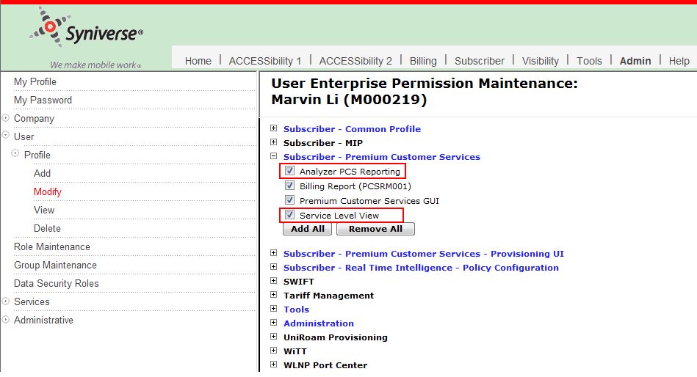

This user should see these links under **Subscriber** tab. Logically all the links should be clicked and verified if they are showing properly or not.

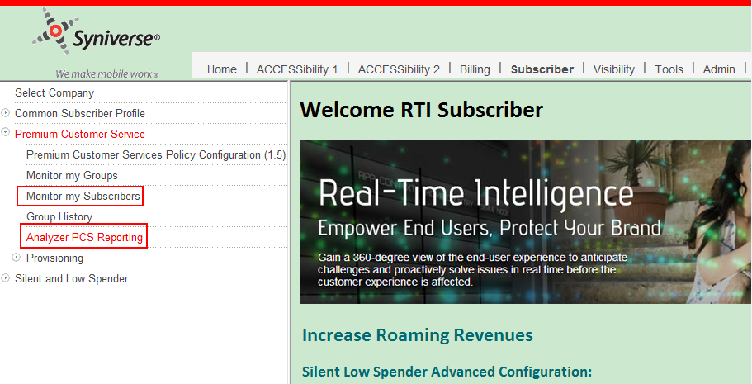

### Customer Test Company

No new company permission is added. Nothing needs to be verified in company permission level

### Customer Test Company User

Assign the two user permissions to this company User.

User permission **Service Level View** user will bring **Monitor my Subscribers** link, and user permission **Analyzer PCS Reporting** user will bring **Analyzer PCS Reporting** link

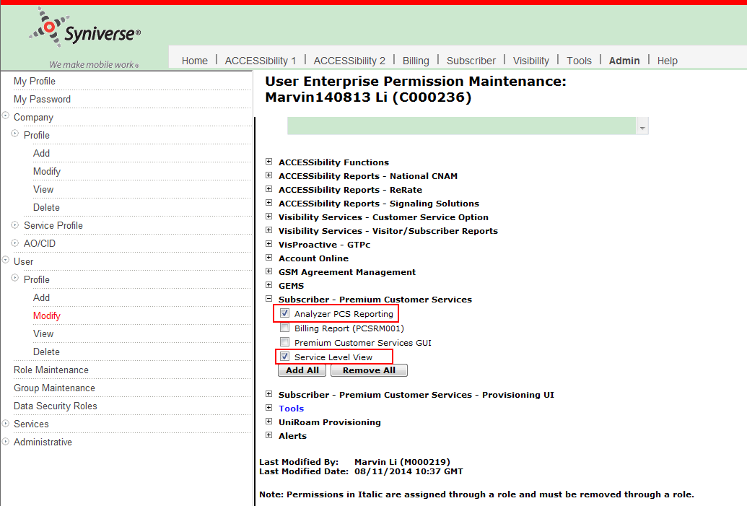

This user should see these links under **Subscriber** tab. Logically all the links should be clicked and verified if they are showing properly or not.

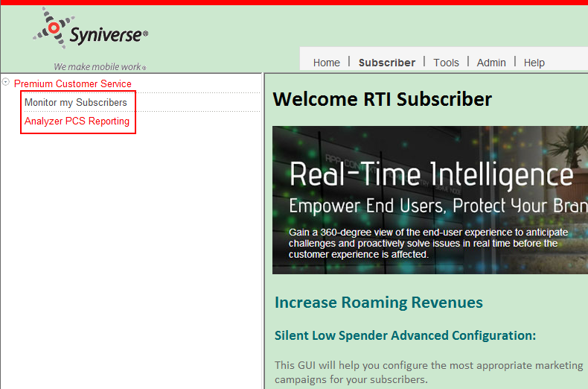

# Test Procedures

Centralized Testing has created a system test plan and executed it in the System Test environment. Please see their documentation and completion report for more information.